Project Design Phase
Solution Architecture

Date | 11 September 2026
Team ID | NA
Project Name | Metro Ticket Generating System in ServiceNow
Maximum Marks | 4 Marks

Solution Architecture Overview
The solution architecture bridges commuter needs with ServiceNow platform capabilities by establishing an automated, contactless transit ticketing flow:
- Client & Presentation Tier: Commuters access the responsive Service Portal (/sp) using desktop or mobile browsers. The catalog item interface (Book A Metro Ticket) accepts transit route parameters without requiring local client installations.
- Dynamic Scripting & Logic Tier: Client-side form interactions evaluate origin and destination stations using an onChange Catalog Client Script. This script calculates Single (type_of_journey = 1) and Return (type_of_journey = 2) fares in real time based on station coordinates. A Catalog UI Policy manages field visibility, displaying and enforcing the enter_payment_mode variable when "Others" is selected.
- Checkout Interception & Widget Rendering Tier: Upon form submission, an onSubmit script intercepts the checkout event and constructs an encoded payload containing the unique record identifier (sys_id). The script invokes an spModal dialog housing a custom widget (metro_qr_widget), which interfaces with a dynamic QR generation API to present a 250x250 scannable 2D barcode directly on screen.
- Data Management & Security Tier: Station reference lookups are retrieved from the custom table u_metro_station_details. Confirmed bookings trigger the creation of standard ServiceNow request records (sc_request and sc_req_item). Table-level Access Control Lists (ACLs) permit public read access for station selection while restricting record manipulation to administrative roles.
- Physical Turnstile Integration Tier: Station Automated Fare Collection (AFC) turnstiles equipped with optical barcode scanners read the mobile QR pass, validating transit authorization against the booking token.
Solution Architecture Diagram
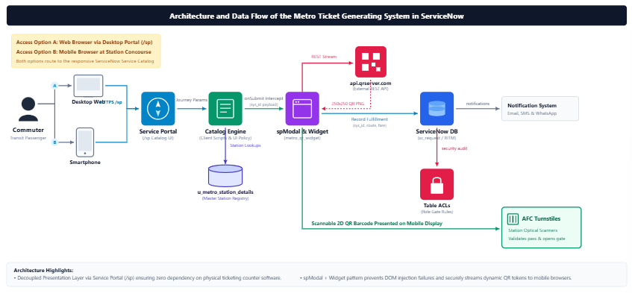
Architectural Component Mapping
Architectural Component | Implementation Layer | Operational Description | Platform Mechanism
Commuter Access Interface | Presentation Tier | Enables commuters to access the ticket booking item on web or mobile devices. | Service Portal (/sp), Catalog Item (Book A Metro Ticket)
Dynamic Fare Processor | Business Logic Tier | Evaluates station origin-destination sys_ids and multiplies passenger counts against route matrix rates. | Catalog Client Script (onChange on no_of_passengers)
Payment Mode Validator | Business Logic Tier | Evaluates payment mode choices and toggles supplementary input variables when required. | Catalog UI Policy (Mode of Payment = Others)
Token Interceptor Engine | Orchestration Tier | Intercepts the checkout submission, passes the record sys_id, and renders the modal ticket display. | Catalog Client Script (onSubmit), spModal API
Dynamic QR Generator | Integration Tier | External REST API that receives encoded ticket URLs and streams high-contrast 250x250 PNG barcodes. | api.qrserver.com REST Integration
Station Master Store | Relational Data Tier | Custom table storing active transit stations, unique abbreviations, and routing identifiers. | Custom Database Table (u_metro_station_details)
Transactional Order Store | Relational Data Tier | Enterprise database tracking passenger requests, fulfillment logs, and variable state entries. | Core Schema Tables (sc_request, sc_req_item)
Security & Access Layer | Security Tier | Enforces read availability for commuters while restricting schema modifications to administrators. | Contextual Security & Role-Based ACLs
AFC Turnstile Validation | Edge Infrastructure Tier | Optical gate scanners at metro entry points that read 2D barcodes from mobile screens to clear passengers. | Automated Fare Collection (AFC) Gate Scanners

